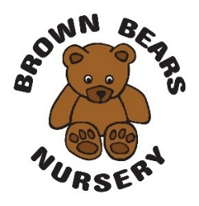
Safe and Respectful Care

The safe and respectful care policy may complement the Intimate Care Policy.

At Brown Bears Nursery we believe that all children need to feel safe, secure and happy. This involves nursery staff being responsive to children’s needs, whilst maintaining professionalism. This includes giving children cuddles and changing children’s nappies or clothes.

To promote good practice and to minimise the risk of allegations we have the following guidelines:
- Although we recognise it is appropriate to cuddle children, we give cuddles only when sought by children needing comfort to support their emotional development. Staff are advised to do this in view of other children and practitioners, whenever possible. We recognise that there may be occasions where it is appropriate for this to happen away from others, such as when a child is ill. In these circumstances, staff are advised to leave the door open. It is the duty of all staff and the manager to ensure that children are appropriately comforted and to monitor practice
- When changing children’s nappies or soiled/wet clothing, we leave the doors open, where appropriate
- We discourage inappropriate behaviour such as over tickling, over boisterous play or inappropriate questions such as asking children to tell them they love them and we advise staff to report any such observed practice
- Staff are respectful of each other and the children and families in the nursery and do not use inappropriate language or behaviour, including during breaks
- All staff are aware of the whistleblowing procedures and the manager visits the rooms throughout the day to ensure safe practices.

If a parent or member of staff has concerns or questions about safe care and practice procedures or behaviour they consider as inappropriate, including between staff members, they are urged to see the manager at the earliest opportunity. Management will challenge inappropriate behaviour in line with the supervision/disciplinary or whistleblowing procedures. If the concern relates to the manager and/or nursery owner then parents should contact Ofsted 0300 123 1231or the local safeguarding partner (LSP) 0208 379 5555.

This policy was adopted on | Signed on behalf of the nursery | Date for review
August 2022 |  | August 2023

